**Project 3**

**At this point,** I feel like changing my project topic. Before I was working on website that is given to faculty for making their communication with student easier. But now I want to move my project in a different direction.

I thought about an idea to design an interface either on paper or computer screen that will help teachers to remember student’s names. I am narrowing down my project to limited audience. Also, I want to write Executive summary, persona, scenario before design so the reader, as well as designer, will have a clear idea about where he is going. Hope you will like it.

**Executive Summary**: “Helps you to call students by their name on the spot.”

**Criteria:** Our target users are teachers in BYUI. We want to help them to remember students names in their class. So my criteria for this project to be successful are listed below:

Learnability(40%): This is our main goal, to learn students name.

Simplicity(20%): Nobody likes complex interface. People will lose trust and motivation to learn if they find our system to be complex and hard to learn.

Familiarity(20%): I think it helps a lot for a human to differentiate things If they know the things before. With this statement, I want to say that the picture should be familiar or should be a new picture of student. Also, just by looking student face if you feel like you have talked to that student before that helps a lot.

Efficiency(15%): Efficiency is important in any design but as a student, I don’t expect any professor to remember my name on the spot. It puts good impression on student but not a priority 1.

Visibility(15%): I don’t want the list to be 2 papers wide and 3 papers in length so I have to put 6 papers on my desk to get all people names.

**Persona**: Brother Manly is a new faculty member in BYUI. He has never seen a lot of student in his class before since he is a new faculty on campus. He teaches classes like Operating System an Data Structure. He frequently has problem in calling student by their names. He has asked his class to think of a design that can help him remember student names more easily.

**Scenario: Brother Manly was walking in** computer science department’s building and he meets one guy who is in his class. He remembers his face and also the question he asked just one hour ago in class but name. He scratches his head to remember his name but couldn’t remember. Since Brother Manley doesn’t know his name, brother Manley just says hi and gives a big smile.

**Design:**

Different Ideas to present student names on screen or on a paper that will help teacher remember the student’s name.

**Breadth First Search:**

1. **Sorting student names alphabetically(Name and Picture):**

This is one of the alternatives that can help teacher to remember student names. It has its own advantage and disadvantage.

**Strengths**: the Human brain can memorize things when lists or things are arranged in ascending order. It helps faculty to recognize students with similar name. Easy to find people name if they know the first initials, quick and easy to find, easy to learn and master.

**Weakness:** Doesn’t put good impression on student when teacher goes to the list every time to find a name. Some people might get intimidated when people call by their initials. Fails to meet our goal of remembering name.

|  |  |  |  |
| --- | --- | --- | --- |
| Criteria | Weight | Score | Comments |
| Learnability | 0.4 | 0 | Similar to memorization |
| Simplicity | 0.2 | 1 | Simple but inefficient |
| Familiarity | 0.2 | -2 | No familiarity in people’s face and searching pattern |
| Efficiency | 0.15 | 1.3 | Easy to find people name if you know initials |
| Visibility | 0.15 | 0 | Similar to list of names |

Total = -0.005

1. **Diving people based on sex and language or ethnicity(Name and Picture):**

According to this idea, we divide people with similar categories not only based on their colors or attitude in class. But it can be in any specific way according to faculty requirement and one can manipulate the list as he wants. It will simple like drag and drop. And if someone likes the print copy he/she can print after forming the certain list.

**Strengths:** helps in pointing/remembering students who are active in group or class. It creates closer relation between student and teacher. Easy to know more about students, not only names eg: where they came from, mission served, hobbies etc.

**Weakness:** Bad impression on student, may think teacher as a racist or sexist. Can become an issue. It can be illegal in some place.

|  |  |  |  |
| --- | --- | --- | --- |
| Criteria | Weight | Score | Comments |
| Learnability | 0.4 | 1 | Usually, people with similar nature make a group and sit together in a class but not always |
| Simplicity | 0.2 | -1 | Makes even more complex, might face issues |
| Familiarity | 0.2 | -0.5 | Just know people by their face nothing to do with name |
| Efficiency | 0.15 | 0.5 | Easy to know people but not name |
| Visibility | 0.15 | -1 | List is still unclear, what if people with similar nature sits in different place in class. No pattern. |

Total = 0.02

1. **Placing people name in same way as they sit in class(Name only).**

In this design, we put the name of people in the same way they sit in class. Class contains 30-50 people normally, and it will be hard to put all the people names and picture in the same place.

**Strengths:** Easy to find name as our human brain is good in memorizing image, higher efficiency in searching name even in class. Easy to remember name if we can link people face and where they sit in class.

**Weakness**: How can teacher remember a (50 * number of classes he teaches) students and their face and where they sit in class so they can relate their sitting position to the name. Design is totally vague as we are trying to relate names with our visual memory but lacks an image.

|  |  |  |  |
| --- | --- | --- | --- |
| Criteria | Weight | Score | Comments |
| Learnability | 0.4 | -1 | It disobeys the law of simplicity by visual learning |
| Simplicity | 0.2 | -0.5 | It disobeys the law of simplicity by visual learning |
| Familiarity | 0.2 | 0 | Since it is easy to remember people face in class |
| Efficiency | 0.15 | -1 | Can only tell people name if they sit in same place always which is not the case |
| Visibility | 0.15 | -1 | Student can sit in any place. |

Total = - 0.8

1. **Placing picture in the same way as they sit in class:**

This design assumes that student sits in same place every class time.

**Strength:** Very easy to look student in attendance sheet and look their name and image. Easy to link student face where they sit and memorize name in same way. Helps in recognizing students and takes less time to mark the attendance sheet.   
 This hypothesis assumes that even student sits in different place they will go back to their own original place next time.

**Weakness:** What is student comes late and sits in different place. How will teacher know student at the beginning of the semester? Have to scroll the list left and right and top to button if the class is big.

|  |  |  |  |
| --- | --- | --- | --- |
| Criteria | Weight | Score | Comments |
| Learnability | 0.4 | 2 | Easy learning process. If teacher has talked to each student in class at least once. |
| Simplicity | 0.2 | 1 | Simple and easy to find if you know where they sit in class |
| Familiarity | 0.2 | 1 | Easy to remember name if you know their image in mind |
| Efficiency | 0.15 | -1 | Easy to find people name just by looking/remembering their sitting position in class. |
| Visibility | 0.15 | -2 | Have to scroll left and right up and down |

Total = 0.75

**Depth First Search for (Placing picture in the same way as they sit in class):**

From the above test, we can see that we got highest score in **"picture in the same way as they sit in class.”** We want o further refine this process and make it even better and smooth way to learn people name. We want to polish our way and make it best way to remember student name.

1. **Eliminating horizontal scrolling:**

**Since** the width of the class will be big, we want to eliminate the horizontal scrolling from our interface. And for printed format type we will print in Landscape format. Usually, the maximum people in first row in BYUI is 14(eg: STC has biggest sitting capacity).

**Strength:** Higher Efficiency, Very easy in bigger screen, User-friendly, similar to what you see with your eye in class, feels like you are in class with people with their name card.

**Weakness:** The only weakness is what to do in the first week of the class. Other than that vertical scrolling does not bug people much. Again, it assumes that they will sit in same position for entire semester.

|  |  |  |  |
| --- | --- | --- | --- |
| Criteria | Weight | Score | Comments |
| Learnability | 0.4 | 2 | Easy learning process. If teacher has talked to each student in class at least once. |
| Simplicity | 0.2 | 1 | Simple and easy to find if you know where they sit in class |
| Familiarity | 0.2 | 1 | Easy to remember name if you know their image in mind |
| Efficiency | 0.15 | 1 | Easy to find people name just by looking/remembering their sitting position in class. |
| Visibility | 0.15 | 1 | Only need to scroll up and down and need to look multiple pages which is fine. |

Total: 1.1

1. Eliminating vertical scrolling:

In this case, we are trying to put all the people on one page may be vertical/portrait or inside one screen may be with multiple pop-ups.

**Strength:** Everything visible on one page**.**

**Weakness**: Very unclear and over information in one single page.

|  |  |  |  |
| --- | --- | --- | --- |
| Criteria | Weight | Score | Comments |
| Learnability | 0.4 | 1.5 | Really good when the user uses bigger screen for |
| Simplicity | 0.2 | 1 | Similar to the way teacher sees everyone in class as long as they seat in same place |
| Familiarity | 0.2 | (2+(-2)) = 0 | Good as long as all people can come inside one page which not the case in printed format. |
| Efficiency | 0.15 | -1 | Hard to find a student from 50 students in one sheet of paper |
| Visibility | 0.15 | -2 | Hard to find a student from 50 students in one sheet of paper |

**Total = 0.35**

1. **Eliminating vertical as well as horizontal scrolling and using pop-up to enlarge image:**

This method can be efficient in computer and one with touch interface. But this option is useless in paper interface. We want something that can work both in paper and screen format. So this approach fails before it can go to evaluation section.

1. **Vertical scrolling with pop-up icon on the side that can be chosen by user.**

It is for making our number 1. More efficient so faculty can relate people name with some icon they can display on screen or on a paper. The design will have a small passport size picture with an icon matching that student name on the side. We also want to add a link to student names and picture so that clicking on name will take to his profile and clicking on image will enlarge image. But, I feel it has nothing to do with our priority 1 and 2 it is an additional feature.

**Strength:** Easy to remember name. eg: Sometimes people name or their character, or their looks reminds us of something that we can relate them with. Since Icon is additional that way we can have all the benefits of number, add some benefits to it, and without losing many points in other section.

Weakness: As we know our design has a flaw that we assume student to sit in same place. Plus, having colorful small icon on side can decrease simplicity of design.

|  |  |  |  |
| --- | --- | --- | --- |
| Criteria | Weight | Score | Comments |
| Learnability | 0.4 | 2 | Easy learning process. If teacher has talked to each student in class at least once. |
| Simplicity | 0.2 | 0.8 | Simple and easy to find if you know where they sit in class |
| Familiarity | 0.2 | 1.2 | Easy to remember name if you have their image in mind. Plus one might feel easier in linking image and icon. |
| Efficiency | 0.15 | 1.4 | Easy to find people name just by looking/remembering their sitting position in class. Plus easier to match with icon they remember outside the class. |
| Visibility | 0.15 | 1 | Only need to scroll up and down and need to look multiple pages which is fine. |

Total: 1.56

1. **Testing mode:**

**This mode is** very helpful in electronic screen than in computer but it can also be carried out in paper format. It is an additional feature that can be added in our previous section 4. (**Vertical scrolling with pop-up icon on the side that can be chosen by user)** In this mode we will have 3 different option to choose from:

1. **Normal mode** as section 4.
2. **Testing mode** which will only display picture and no name and icon.
3. **Icon mode** which will display pictures and icon but not name.

Personally, I liked this approach. But, this design goes above and beyond our objective. I believe our faculty has more important job to do that just memorizing our name. As being the only stakeholder of this design I don’t want to take this design process any further.

**Prototype**: Our final design does not have much links and buttons**. It is** designed to be user-friendly and as simple as possible. But, interactive interface one can click on student name and it will show the student profile and clicking on name will enlarge the picture. It is just an additional feature. Our main goal is to help faculty to remember student names.

**Scenario (A example scenario for describing our prototype):** Brother Manly, our data structure teacher comes to class. Today he sees very fewer people attending his class. So, he thinks of writing the people name who came to class to give extra credit which informing anyone. He pulls up his class attendance file on his screen and starts looking at people who have come and hasn’t come.

Describing our interface, the red line is the person’s name, major and his address. The purple circle is icon which user needs to request developer to put them there. Also, the naming of icon will be done in such a way even novice user can edit the icon as their needs. Black box holds your name, info, and picture too. And the scrolling bar will be on the right side which can be scrolled with mouse.

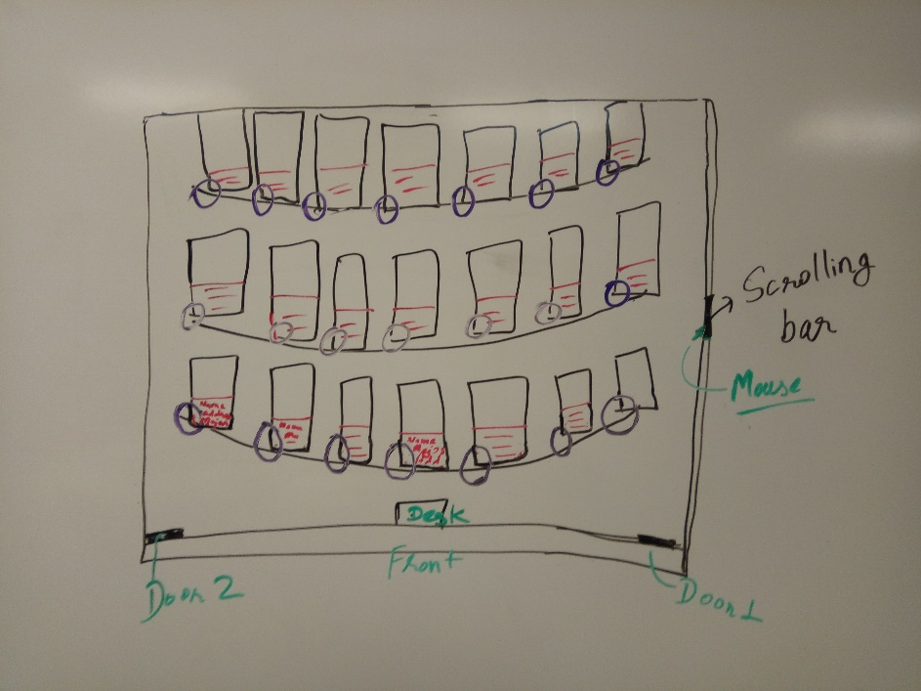

1. The home screen or the first page. It is a graphical file that shows all the student’s information and their seating position in class. The right-most part is the scrolling section. In the front, it has two doors and a desk. Brother manly look to the student pictured in the screen and writes their names on a sheet of paper. He finds it pretty easy as he knows which student sits where in a class so he doesn’t have to look over the whole screen to find one person.

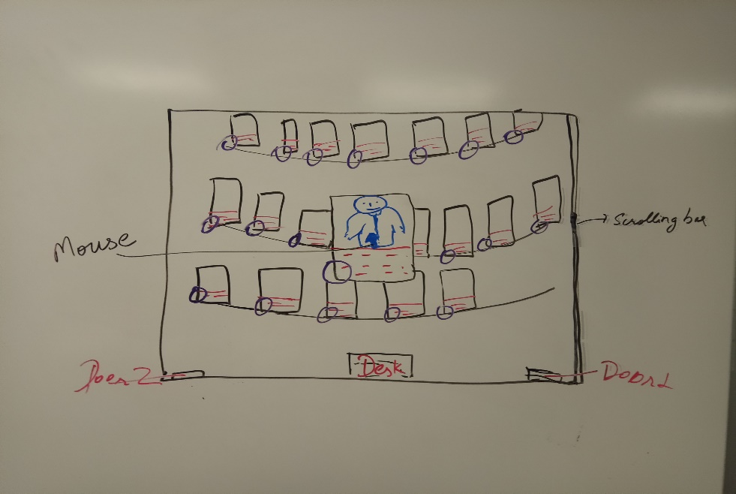

1. The picture in the attendance file was pulled from I-card which was taken when student came as a freshman on campus. There was one student in class, brother manly could not be sure if that’s the same guy. He uses his glass and enlarges the image by clicking on his image. After looking to bigger images he gets sure that is the same guy.

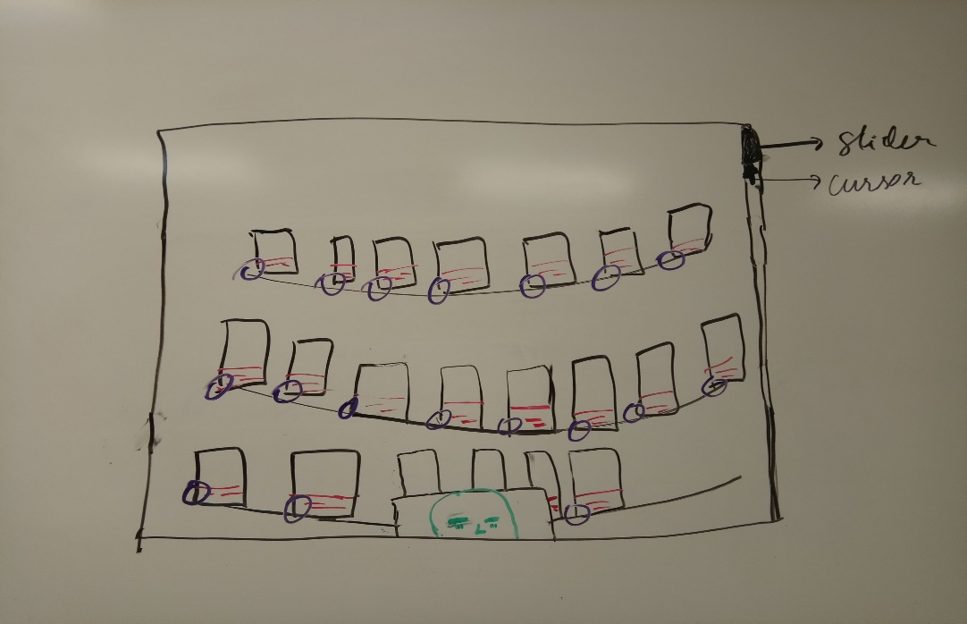

1. The user will be able to scroll even while the image is enlarged. One needs to click again to bring image to normal position. Here in our 3rd image, I have shown that our user is scrolling the page up and down while our image is still big.

**Specification :**

**Executive Summary**: “Helps you to call students by their name on the spot.”

**Criteria:** Our target users are teachers in BYUI. We want to help them to remember students names in their class. So my criteria for this project to be successful are listed below:

Learnability(40%): This is our main goal, to learn students name.

Simplicity(20%): Nobody likes complex interface. People will lose trust and motivation to learn if they find our system to be complex and hard to learn.

Familiarity(20%): I think it helps a lot for human to differentiate things If they know the things before. With this statement, I want to say that picture should be familiar or should be new picture of student. Also, just by looking student face if you feel like you have talked to that student before that helps a lot.

Efficiency(15%): Efficiency is important in any design but as a student, I don’t expect any professor to remember my name on the spot. It puts good impression on student but not a priority 1.

Visibility(15%): I don’t want the list to be 2 papers wide and 3 papers in length so I have to put 6 papers on my desk to get all people names.

**Persona**: Brother Manly is a new faculty member in BYUI. He has never seen a lot of student in his class before since he is a new faculty on campus. He teaches classes like Operating System an Data Structure. He frequently has problem in calling student by their names. He has asked his class to think of a design that can help him remember student names more easily.

**Scenario: Brother Manly was walking in** computer science department’s building and he meets one guy who is in his class. He remembers his face and also the question he asked just one hour ago in class but name. He scratches his head to remember his name but couldn’t remember. Since Brother Manley doesn’t know his name, brother Manley just says hi and gives a big smile.

**Prototype:** Please read above, I didn’t understand the way question was written.

**Detail Design:**

**The combined section 1 and 4 in breadth search first can describe our detail design:**

Our design is very simple. It is designed in such a way that we can use this design in paper as well as electronic format. For the control, we have a mouse which can click only in picture and name of the person. The other thing that user will be able to do is scrolling up and down the list of people. For putting icon in the side of image it can be done only by web department on campus under the request of faculty. Also, the naming of icon will be done in such a way even novice user can edit the icon as their needs. Our final design in paper and in computer will look like picture below. In paper it will be printed horizontally.

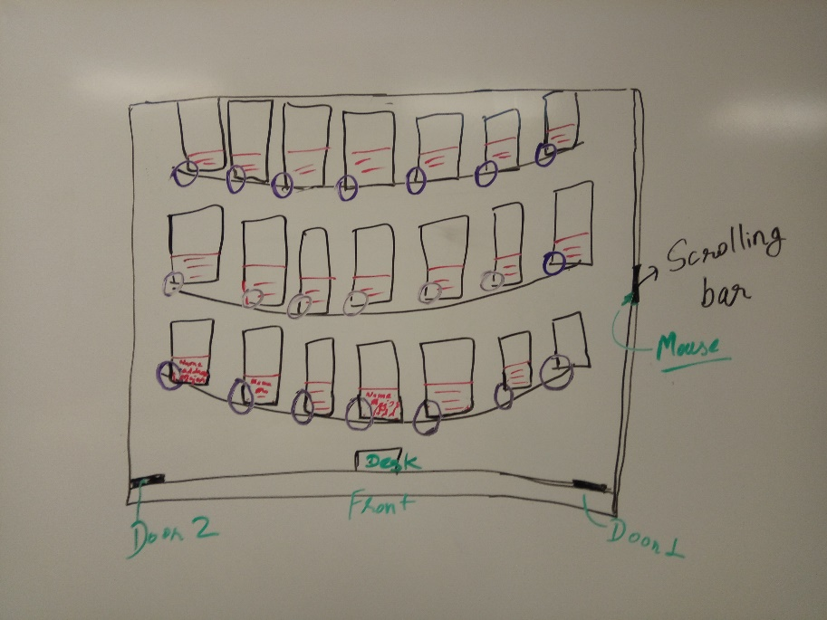

The circular thing going around people is a desk and they will be seated in specific format in every class. Every class has its own format of seating people. Our task is to make an outline of class(it can be anything but not much variety) and we have to place each student picture corresponding to his seating position in class. After the picture and information have been placed we are done with paper format of our final design. For the computer part or the electronic part, it is clearly described in prototype section.